Michelson interferometer

The Michelson interferometer is one of the most important and versatile instruments in optical technology. Michelson used this device to search for a preferred direction for the speed of light. The failure of this search is the cornerstone of Einstein’s theory of special relativity. The two largest examples of this instrument are located in Richland, Washington and Livingston, Louisiana. These devices have perpendicular arms each 4 km long and an optical system designed to detect interference fringe shifts much on the order of one part 10²³ of a wavelength of light. This ambitious project is attempting to find supernova explosions, gamma-ray bursts and other exotic astrophysical phenomena that generate gravity waves that can cause tiny changes in the length of one arm relative to the other. (Website: http://www.ligo.caltech.edu).

This type of interference, that relies dividing the amplitude of light, is used in numerous applications and instruments that include determination of optical flatness, all laser cavities, Fourier transform spectrometers, and more.

You will use the Michelson interferometer to observe the interference pattern of monochromatic light from a He-Ne Laser and also from nearly monochromatic light from a sodium lamp.

- Introduction
An interferometer is generally defined as an optical instrument which produces interference patterns by the division of one beam of light into one or more parts. These parts travel different paths and are ultimately brought together to yield the interference effects. The resultant patterns depend of the optical paths traveled by the several beams. Consequently, the interferometer determines differences in optical paths.

- Learning goals
At the end of this lab you should be able to
- Use the Michelson Interferometer to observe interference pattern by division of amplitude.
- Use a point source of light (a laser with lens) to observe non-localized fringes displayed on a screen.
- Measure the wavelength of laser by counting diffraction fringes.
- Observe localized fringes formed by an extended source (sodium lamp).
- Determine the splitting in sodium D lines by measuring separation of “washout positions” in the spectra (this is high resolution spectroscopy).
- Observe white light fringes by determining the equal path length condition for each arm.

- Procedures
IMPORTANT
- Before you start this lab, please remove any jewelry, watches, rings, etc. as reflecting surfaces will interfere with your measurements. Place those somewhere safe where you will find them when you are finished.
- Every time you turn on the laser, you must turn laser warning sign on (if available).
  - If in a different room, lock doors to prevent entry.
- Be careful of this laser beam. Do not stare into “direct” reflections off the lens or other surfaces.
- The instrument is sensitive. Do not use until you understand how it works.
- Do not attempt to wash mirrors or other optics.
- Do not touch the mirrors and optical elements. A finger print can leave behind oils that cannot be cleaned and that corrode optics coatings.

Experimental setup
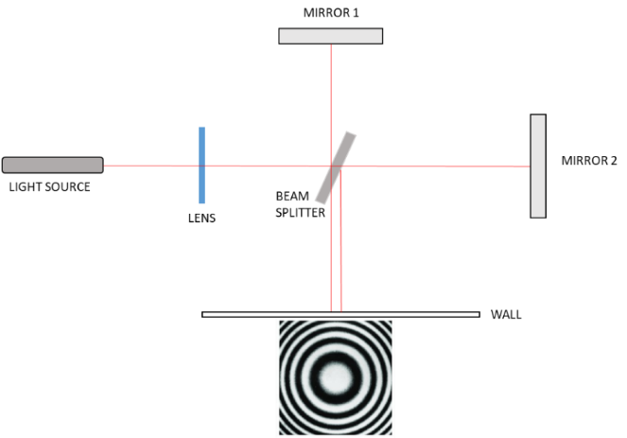

Simplified sketch of the experimental setup.

A typical Michelson interferometer consists of a beam splitter, and two mirrors. One mirror must be translatable along its arm (mirror 1 on our setup). The other mirror must have tilt adjustments (mirror 2) so that the image of mirror 2 in mirror 1 is adjusted so that it appears perfectly parallel to mirror 1. In addition the path along arm 2 (to mirror 2) usually contains a compensator plate so that either beam of light (from mirror 1 or 2) has travelled through the same thickness of glass before exiting and forming an interference pattern.

Lens. This lens is part of the Michelson instrument. It is set in the path of the light to help generate divergence of light that passes through the Michelson. That divergence allows rings to form based on the condition that light reaching a different angle has travelled distinct path differences. The lens effectively makes the laser appear as a point source at its focal length. This also helps to enlarge the interference pattern. It may be useful to use a second lens to help enlarge the pattern further for best viewing, depending on the geometry of the setup. It can also be useful to view the laser beam go through the interferometer with no lenses in order to help achieve optimal instrument alignment.

In our setup a second lens is placed near the laser to help expand the laser beam and provide a highly viewable interference pattern. Overall alignment procedures are discussed below. A significant part of the overall alignment will be done for you prior to using the instrument. Steps in italics are components you should not need to adjust.

Setup of the He-Ne laser and Michelson interferometer
- The height of the laser should be adjusted so that the optics of the Michelson interferometer are on the path of the beam. Finer adjustments could be done later moving up and down the interferometer.
- Adjust the laser beam so that it is fairly level. To check this I mark a position on a target (paper on a box) and check the position of the laser beam near the laser and at the far end of the table. If the laser is not well leveled, the beam position will change more than a couple centimeters up or down between the two positions. If that is the case, some gross adjustment may be accomplished by loosening and tightening the laser mount screws.
- With the laser level and interferometer out of the way, place the external lens approximately 10-15 cm in front of the laser. Adjust both lateral position, height, and rotation of the lens so that the spots reflected from the front and back surfaces of this external lens are fairly well positions on top of each other (they are visible on the front surface of the laser). This ensures that the lens is square with the beam. Check that the height is still within a few cm of level across the table length.
- Move the lens closer to the laser ---approximately 3-5 cm. Again checking and maintaining alignment from steps 2 and 3.
- You may now place the Michelson into the laser beam with the Michelson integrated lens rotated down/out of the way.
  - The instrument should be placed at the far end of the optical breadboard away from the laser—this is approximately a 70cm away from the lens.
  - Physically move the apparatus to view the laser light hitting reasonably well centered in the mirrors. You may need to adjust the height of the interferometer.
  - View the light hitting a target (wall or a box) out from the exit path where you will see several spots. DO NOT STARE INTO THE APPARATUS WITH LASER ON.
  - Adjust mirror 2 tilt knobs so that the spots overlap. You may be able to see interference at this time (you should).
  - Readjust instrument position and mirrors till you are able to see a bullseye pattern. It does not need to be perfect.
  - If not in place rotate the instrument lens so that it is well centered, upright, and light is still visibly hitting and filling both mirrors (physically move instrument until achieved)---Readjust instrument and mirrors until a good bullseye (Airy pattern) is seen on your target screen.
- Steps 1-5 should generally pretty close to set up, but you may (will) need to be expert at setting up from scratch for your oral review.
- Now that you observe He-Ne laser bullseye fringes (Airy Pattern) on the screen we can use other instrument adjustments.
  - One of the mirrors is moveable and uses two knobs to adjust the position.
  - The fine adjust knob is a long rotatory axis. Pull up on the entire fine adjust axis to disengage. Push down to engage.
  - The gross adjust knob is the smaller wheel down below. The rotatory axis must be disengaged before turning the gross adjust knob. Once the fine adjust is disengaged the gross adjustment knob can be moved freely.
  - Each smallest turn on the gross adjust wheel makes the moving mirror translate by 0.010mm, or 10 μm. That motion is about 20 times the wavelength of light, so you will try to read the mirror position to within a fraction of the smallest division.
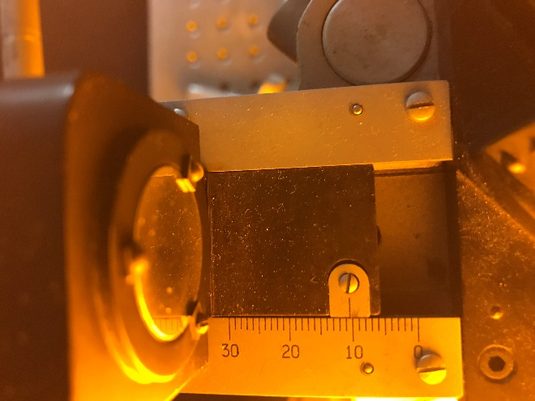
  - You should now play around with moving the gross adjust knob and the fine adjust knob (remember to engage or disengage).
  - When you re-engage the clutch so that the fine adjust knob moves the mirror, you will notice that it takes many turns to cover the slop in the gears and to engage the mirror motion. Once you start counting or want a position measurement, you must move only in one direction. Forward
  - Never move the gross adjust knob while the fine adjust is engaged.
  - If you wish to manually check how far the gross adjust knob moves the mirror you can look down from the top and view the a scale and pointer adjacent to the moving mirror, and observe what you must do to move the mirror one millimeter.
- The stationary mirrors also contains two angle adjustment knobs.
  - If the laser travels through the instrument with no lens in place, then you can observe that changing the tilt on the mirrors will make the primary beam reflection (as opposed to secondary or more) to overlap. You can see this with lenses—but the spots are bigger.
  - When placing a lens back in the instrument, you should still observe the bullseye pattern.
  - We will try to make sure the system is in alignment before-hand in order to display the “bullseye” He-Ne pattern.
  - If you see an interference pattern, you may very carefully make small adjustments to the mirror angle tilt knobs to bring the bullseye pattern into view and keep it well centered.
- As you adjust the motion of the movable mirror with the fine adjust knob, you should observe fringe rings either moving inward, or outward.

Data acquisition
Experiment 1. Determining the wavelength of a monochromatic light
- Once a good pattern of fringes has been obtained, engage the fine adjust knob and remove any slop from the gears. Now take a reading of the mirror position. This is done by looking top down at the scale next to the mirror and adding the markings from the gross adjust large knob.
- Move the translating mirror. For satisfactory precision, count at least one hundred fringes. Every time you move the translating mirror a half a wavelength (light travels there and back again) then a single fringe passes by your marking. The more fringes you count, the better your determination of wavelength. You may want to repeat your counts a few times to improve your average final result. Don’t lose track of counting.

The translating mirror has mm markings along the translation arm of the interferometer. The gross adjust knob has smallest markings of one hundredth of a millimeter. I expect readings to one tenth of the smallest division. Note that this smallest division marking is still about twenty times the wavelength of typical visible light. Nonetheless the fine adjustment knob allows for easy accurate control at the level of single fringes (which indicates control at the half wavelength of light level)!

When you start counting fringes and place a mark in the center of a fringe, you should count that as fringe zero. Then move the mirror so that say 100 fringes pass by. You read initial position at fringe zero, and final at fringe 100. START COUNTING AT ZERO.

- After counting the 100 off (you may count more), take a new reading of the mirror position.
- The difference between the two positions (zero fringe and fringe 100) is the distance traveled by the mirror.
- From the number of fringes passed over, Δn, and the distance traveled by the mirror, d , we may determine the wavelength of the monochromatic light using 2 d = λ Δn.
- When you move the mirror you must engage it and move in one direction only (to avoid any slop or backlash in gears). Therefore, you should always come from low to high when taking measurements. “Don’t look back”
  - This is generally true of any geared system.
  - I recommend starting your fringe counting with a mirror position that is past the Zero Path Difference position (you should know how to determine this roughly). So starting at a mirror position around 10 mm should be good, then move farther. You will see fringes emanating from the center as you create a bigger path difference.
- You should note the significance of being near or far from the very special “Zero Path Difference” condition (ZPD). You don’t want to pass through that special place on the interferometer while counting, since it will make it difficult to count fringes. As the position of moving mirror approaches the position of ZPD, you will observe that the size of the circular interference fringes becomes larger on your observation screen, also your bullseye will probably drift off center, and it will simply be impossible to count fringes near ZPD—but this is why you read these notes first.
- If you count well, and are very careful, you may get a wavelength measurement with very small percent difference from the expected value. Repeating the 100 fringe-counting several times is the equivalent of counting more fringes, and your average should improve your result.
- Some students have either used sensors or video to develop fringe counting methods that allows thousands of fringes to be counted easily.

Experiment 2. Measurement of the sodium doublet separation

The sodium doublet consists of two yellow spectral lines, having wavelengths of approximately 5890 Å and 5896 Å. The 5890 Å is twice as intense as the 5896 Å line. These are commonly known as the D2 and D1 lines in sodium respectively.
- Turn on the sodium lamp, it takes several minutes to warm up. You need to wait until the light coming the lamp is yellow (not pink). Don’t turn it off until the end of the lab session.
- To view the sodium fringes you should use the HeNe pattern to place the movable mirror near the ZPD condition (fringes move inward and start getting thick). The ZPD condition for this instrument is at approximately 8.090mm. Use the gross adjust knob moving to bring the mirror near ZPD.
- You should see the bullseye pattern with relatively fat fringes. Use one of the mirror knobs to misalign the fringes so that you see curved stripes. These are wedge fringes due to slight misalignment of the mirrors—and will help you observe sodium fringes. You should be seeing ~3 to 5 fat striped fringes on your viewing screen (HeNe). Don’t forget which knob you move, you will need this later.
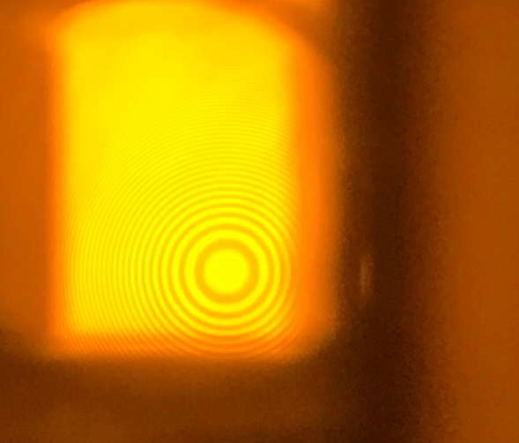
- Turn the He-Ne laser off, and place a box/reflector in front of the warmed up sodium lamp so that a broad diffuse bright yellow light enters the interferometer. Adjust the interferometer position so that bright light passes through the system (you are now staring into the movable mirror). Don’t worry, this is safe. The pattern is viewed with your eyes fairly close to that output beam splitter, ~20 to 30 cm.
- While observing sodium light, and using the same mirror you used last, adjust the mirror tilt knob, you should be able to make fine adjustments (less than a quarter turn either way) and bring sodium fringes into view. You may view stripes immediately upon placing the instrument and simply need to center the bullseye.
  - If you do not see the sodium fringes you may need to get back good He-Ne fringes, readjust to observe HeNe fringes near ZPD again and try a few times. It takes practice!!!!
  - If you continue to have trouble, ask for instructor assistance.
- With adjustments completed (and the He-Ne laser off) you are viewing a sodium ring pattern by looking directly into the movable mirror in the interferometer.
- If the pattern is a set of straight lines, you will need to adjust mirrors to see the yellow bullseye pattern. The diffraction pattern is best seen when your eye is focused at infinity and you are close to the instrument. This is safe to view. It may be uncomfortable to deliberately focus at infinity while viewing. Try a few times, the rings should be clear and easy to see. ---Dr. Colbert’s eyes are permanently fixed at infinite focus.
- There are now two sets of fringe patterns formed (you can’t tell), one for each line of the sodium doublet which have slightly different wavelengths. These tend to overlap so that you cannot distinguish one pattern from the other. But both are there. As you rotate the gross adjust knob, both patterns advance (either both inward or both outward), but at imperceptibly different rates. After many hundreds of fringes passing by you will notice the pattern getting less distinct (low contrast). When the rings from one pattern lie halfway in between the rings of the other pattern (one pattern for each wavelength) –this is called a washout. It is a condition of low contrast between the two fringe patterns, and looks almost like a flat yellow background. You are seeking the mirror positions leading to the most indistinct viewing or washout positions.
- You will measure the positions of about 20 washout positions, and number them 1, 2, 3, 4, and so on.
- In order to see many washouts, you may want to start well below the ZPD position (say at 3 or 4 mm), scan through the ZPD, and well past it. It will be easy to confuse ZPD with a washout. They can be distinguished during data analysis as the washout positions are equally spaced.
  - If you have an apparent washout that is out of place---it may have been ZPD—oops--.
  - If you have a washout that takes twice the distance, you missed one, and can account for it by going 1, 2, 3, …, 5, etc., since you know the washouts are equally spaced.
  - It is necessary for you to count correctly to obtain satisfactory results.

Some theory notes about the sodium lines
The goal of this part of the lab is to determine the spacing between the sodium D lines Δλ (588.9950 nm and 589.5924nm in air). The average of the two wavelengths is 589.1941nm.

In order to determine your measurement of the wavelength spacing consider the following. Let’s say we do not know the separation Δλ. Because these lines are pretty close, what we see is one big blur of a peak with a well-known center at the average wavelength of both lines.
When the rings from one pattern lie halfway in between the rings of the other pattern, you see a washout. At the first washout position (call this washout A), the interference condition for the center of the pattern for the longer wavelength is roughly
2d_{A}=m_{1A}λ₁ (1)

Now for the other wavelength (say the shorter), the pattern lies midway between the other wavelength rings. So it is placed half of a wavelength from the previous position

2d_{A} =(m_{2A}+1/2)λ₂ (2)

So far we are just saying that we have a bright fringe at the center of the pattern for wavelength 1, and a destructive fringe for wavelength 2.

The two different values for m's are both integers so the two integers differ from each other by some integer value n. That is since both are integers then m_{1A}+n=m_{2A} for some integer n. The path length separation between the two mirrors for a particular washout position is then

2d_{A}=m_{1A}λ₁=(m_{1A}+n+1/2)λ₂ (3)

If d is increased to the next washout condition (washout B), then the fringe number for the shorter wavelength has increased by one more fringe than for the longer wavelength. As the path difference is changed then more of the shorter wave fringes pass by than for the longer, it is one more additional wavelength by the next washout position. So the new condition for this very next washout position is

2d_{B}= m_{1B}λ₁=(m_{1B}+n+3/2)λ₂. (4)

You can use these conditions to obtain an approximate expression for Δλ in terms of measurements. Note λ₁λ₂ ≅ (λ_{ave})² since the two wavelengths are close together. Subtracting equations 3 and 4 leads to

Δλ=(λ_{ave})²/(2 Δd) (5)

Where Δd is the space between consecutive washouts. You should be impressed that you are achieving a level of precision in a measurement to about a few thousandths of a nanometer by making measurements of positions (washouts) that are precise to only a few microns. When you make a plot of your washout position vs washout number “n”, then the slope is Δd (change in position per unit change in washout number). So you will be making a graph and determining the slope.

Experiment 3 Whitelight fringes and the ZPD position

Demonstrate to me that you can find white-light fringes. You will measure where that condition is located. You should find white light fringes by any means possible and demonstrate these to me (to verify the effect). Then expect me to mis-align the interferometer, and you should find the white light fringes within one hour. This is your hands on (oral review) portion of the lab. You will report your measured value of the position where you find ZPD (white light fringes) in your final report and data analysis.

